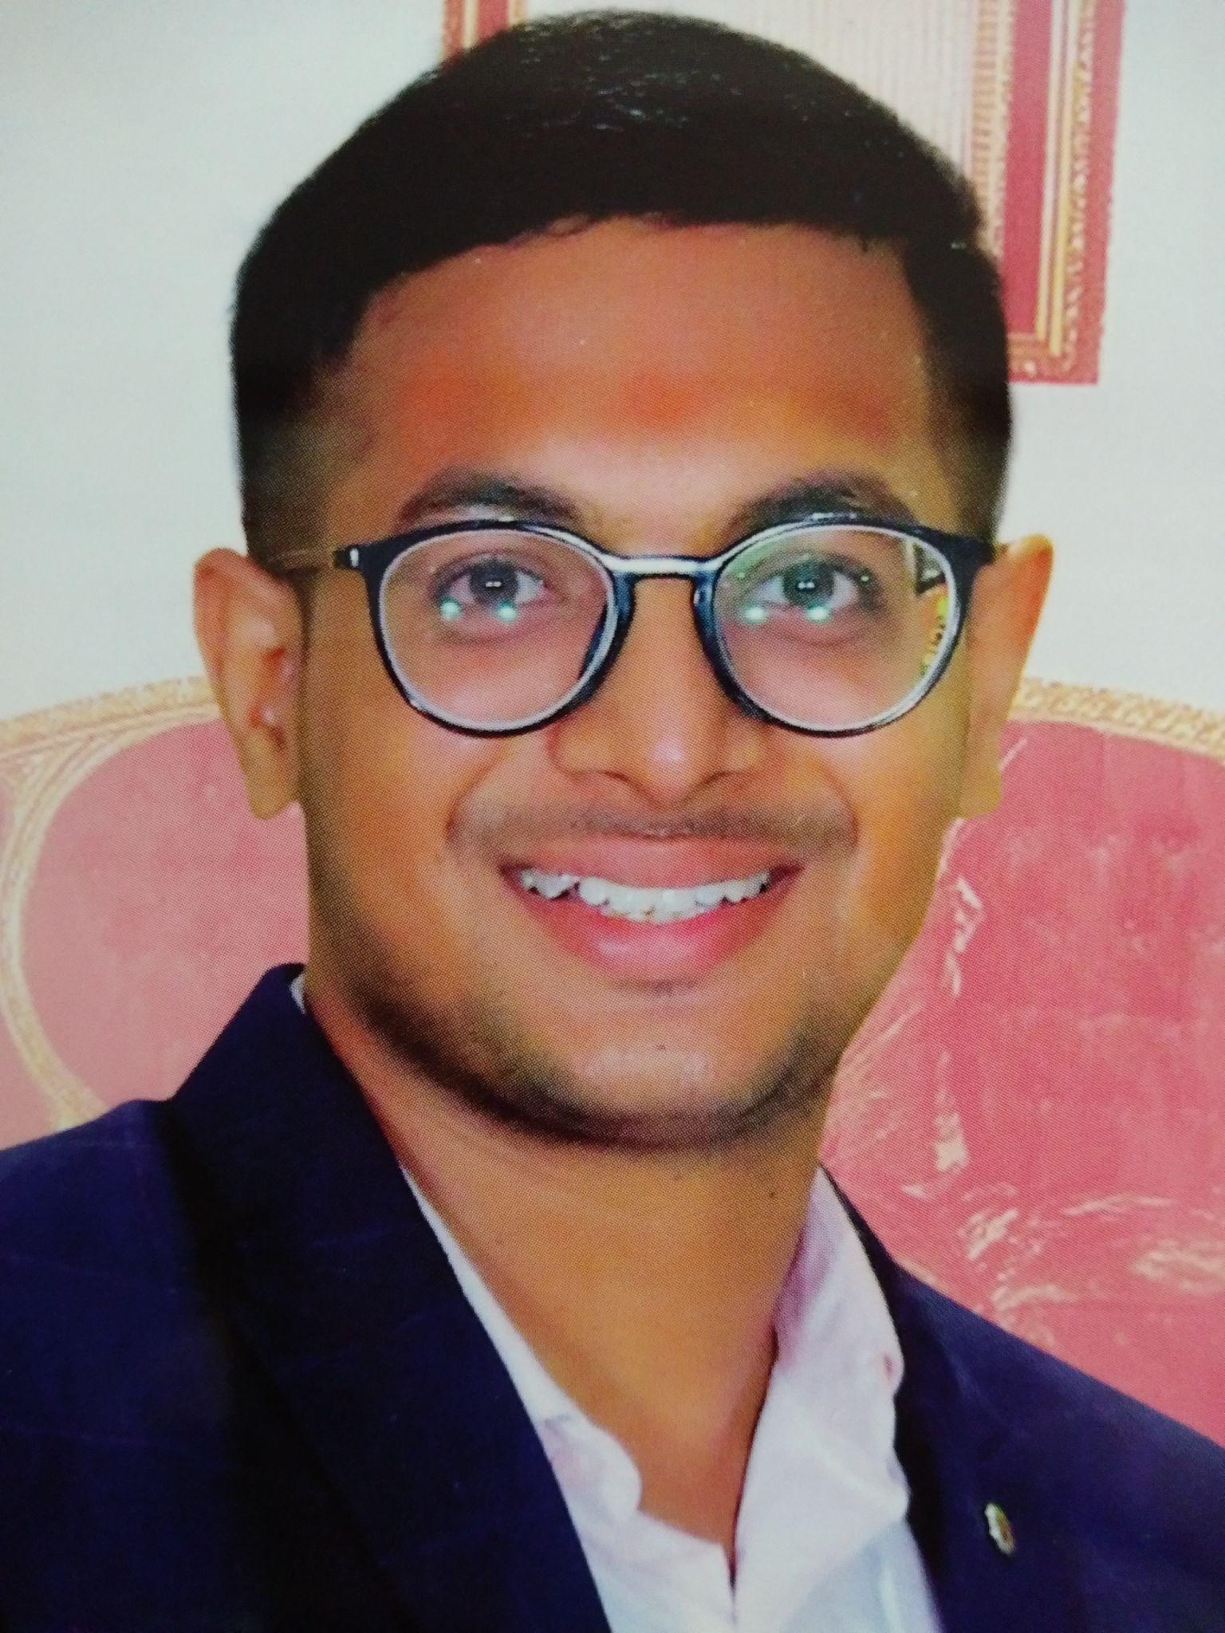
Curriculum Vitae
Chopparapu Ravi Teja
Tempe, AZ
Google Scholar | LinkedIn
E-mail: rchoppar@asu.edu
: ravitejachopparapu1998@gmail.com
Phone: +1 6232687603

Objective | To acquire knowledge and improve my skills so that I can face real world challenges and be able to impact society through meaningful contributions.
Motto | Clean & Green - Healthy & Hygienic World
Education | Qualification Name of the institute Board/University Year of Graduation  PhD (Civil, Environmental and Sustainable Engineering) Ira A. Fulton Schools of Engineering Arizona State University 2025 (anticipated)  Bachelor of Technology (Mechanical Engineering) Velagapudi Ramakrishna Siddhartha Engineering College Jawaharlal Nehru Technological University- Kakinada 2020
R&D Projects | - Name: Study of Microbial Lateral Transport in a 2-Dimensional Porous Media  Name of Centre: WET Center, Arizona State University  Position: PhD Project, since Aug 2023  - Name: ASU Regional Water Quality Monitoring Program  Name of Centre: WET Center, Arizona State University  Position: Research Aide, since Dec 2022  - Name: Innovative Technology for Pathogen and Scale Formation Control for Sustainable Operations of Cooling Tower Systems  Name of Centre: WET Center, Arizona State University  Status: Yet to start in April 2024  - Name of Idea / POC / Innovation / Prototype: Ocean Wave Energy Conversion  Name of Centre: Incubation Centre-VRSEC  Research Position: Principal Innovator  Year of Innovation / Project Started: September 2018  Total Seed Grant (INR): 1000  Published work under this research project: 1(Published paper), 1(Conference Presentation)  Supervisors (VRSEC): 1. Dr. N. Ravi Kumar, 2. Dr. M. Bala Chennaiah  Status: Completed.  - Title Of the Proposal: Biodegradable Polymer Filter Made From Fiber Composites For Addition Of Nutrients To Water  Year of Proposal: December 2019  Total Budget (INR in Lakhs): 41.49  Grant Organization: BIRAC, Department of Biotechnology, India  Proposal Reference No.: BT/TEMP7245/NBM/06/19  Published work related to proposal: 2(Published Papers), 2(Conference Presentations)
Awards | - University Grad Fellowship, Spring’24, Spring’23, Fall’22 | Arizona State University  - Award name: Vijayawada City Police Pratibha Award for Excellence in Intermediate  Date: August 8, 2017  Value: 8000 INR  - Award name: Vijayawada City Police Pratibha Award for Excellence in SSC  Date: August 10, 2015  Value: 5000 INR
Academic Experience | - Graduate Teaching Associate - Environmental Microbiology - Fall 2023 – CEE 467/567 – Arizona State University. Focusing on aseptic techniques, media preparation, microbial culturing assays, Polymerase Chain Reaction, Quantitative Microbial Risk Assessment, Jar Test & Filtration.  - PhD under Dr. Morteza Abbaszadegan, Professor of Environmental Microbiology and Engineering and Founding Director of the National Science Foundation (NSF) Water & Environmental Technology (WET) Center at Arizona State University.  - Skills acquired include Aseptic technique-Media making & culturing bacteria, PCR.  - Familiar with BSL-2 labs, Biohazard waste protocol, autoclaving, chemical handling.  - Research Aide for Regional Water Quality Project- Sampling and Microbial Assays.
Term Project | - Project Titled “A Study on Raw Materials Used for Manufacturing of Carbon Black”.
Professional Body Memberships | - Member at Institute of Engineers- India.  - Member of ASCE – Phoenix Chapter.
Software Skills | Auto CAD, Solid Works, Python, C, C++
Publications | International Journals:  - Ravi Teja Chopparapu, et.al “Ocean Wave Energy- A Step Towards Recharging Batteries'' TEST Engineering & Management, Volume 82 January-February 2020, ISSN: 0193-4120 Page No.8774-8780.(SCOPUS) http://www.testmagzine.biz/index.php/testmagzine/article/view/2226/1988  - Ravi Teja Chopparapu et.al “Biodegradable polymer filter made from fiber composites for addition of minerals and salts to water”, Materials Today:Proceedings, Volume 33, Part 8, 2020, Pages 5607-5611.(SCOPUS) https://doi.org/10.1016/j.matpr.2020.03.713  - Ravi Teja Chopparapu et.al “A Review Article on Water Purification Techniques by Using Fiber Composites and Biodegradable Polymers”, AIP Conference Proceedings 2247, 040007 (2020). (SCOPUS) https://doi.org/10.1063/5.0004069  - Ravi Teja Chopparapu, M B Chennaiah “Color Manufacturing by the Conversion of Microbial Stored Carbon using the Phase Change Principle”, Research Inventy: International Journal of Engineering and Science Vol.13, Issue 6 (June 2023), PP 36-43. https://www.researchinventy.com/papers/v13i6/F13063643.pdf  International Conference Papers:  - Veda Vyas Chillapalli, Dr. M. B. Chennaiah, Ravi Teja Chopparapu et.al “Integrated Water System: A Study On Rural And Urban Water Management”, InDACON’20 at Indus University-Ahmedabad, Gujarat, India.  - Naga Sai Dintakurthi, Dr. M. B. Chennaiah, R T Chopparapu et.al “Urban Water Distribution System: A Study On Water Supply Challenges”, InDACON’20 at Indus University- Ahmedabad, Gujarat, India.
Student Leadership | - Students Acceptable President for the Arizona State University Graduate & Professional Student Association (ASU GPSA) 2023-24.  - General Elections - 967 VOTES (52.84%)  - Run-off Elections - 193 VOTES (70.18%)
Professional Sports | - Trained for Tokyo Olympics 2021 Track and Field in 100m Men.  - School Champion in 100m and 200m Athletics.  - Competed in Inter School Cricket Tournament (Nori Siva Ramakrishna Trophy-2013).  - Participated in Inter School Badminton Tournament.  - Competed in District Swimming Championship (under-14).
Entrepreneurial activity & Personal Achievements | - Founder of Brand “BLISS” in my undergrad college and made my friends as partners and we were a Successful Team under my Leadership.  - Started a YouTube channel “BLISS TV” in November 2019. https://www.youtube.com/channel/UC-rI0esA0GaxO8F3F9qXpIA  - Maintaining a Blog “BLISS BLOG”.  https://ravitejachopparapu1998.blogspot.com/  - Started a food stall “BLISS BIRYANI '' at AFOSEC-2K18 with a Revenue of 90,000 INR & “BLISS CHINESE COOKERY” at AFOSEC-2K19 with a Revenue of 70,000 INR.  - Performed Personal Research on Employee Psychology and Ownership/Employer mindset for a Month in 2019 in Nellore City, India.  - Maintaining a service-oriented trust “CHOPPARAPU SEVA TRUST” and adopted a needy person (beggar) found at railway station in May '17. http://chopparapusevatrust.simplesite.com/ https://www.youtube.com/watch?v=UpC5sgQvtq  - Story Writer – 5 stories narrated in 2021 in various genres.
Personal Details | Date of Birth : December 28, 1998  Sex : Male  Nationality : Indian  Languages Known : English, Telugu, and Hindi.

